This is restaurant admin module : 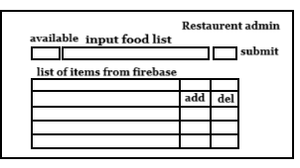

In this page:

1. Available / Not Available Button :- by jus clicking in this button restaurant details page set value food available or not
2. Input Field and submit button:- In input field we simply add food item that is showing in restaurant details page.
3. Table with add(update) and delete button where we see food item list we added and also we can update the item and it will change in the firebase also.

This is restaurant details page :

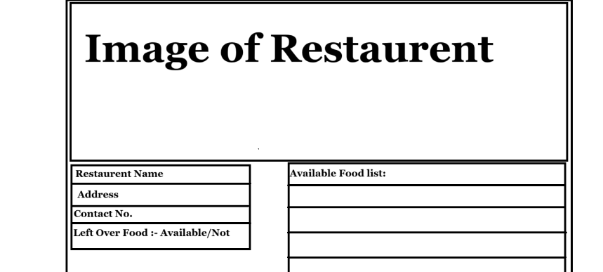

Most of the data comes from admin side :

1.image

2.restaurent name

3. address

4. contact no.

Data comes from restaurant admin page:

1. Left over food available.
2. Available item according to person.